Ivy Tech Community College - SDEV 265
Weather Forecast Validation Testing

Prepared by:
Carlos Cuevas Cadena
Marcilia Alves Machado

Introduction
The purpose of validation testing was to confirm that the Weather Notification System correctly accepts valid user information, rejects invalid or incomplete data, and performs the required registration, update, and unsubscribe functions.

Results and Corrections

The valid registration tests were successful. When a correctly formatted email, state, and city were entered, the application sent the data to the backend and displayed a confirmation message.
During testing, the form initially allowed incomplete information to reach the backend. JavaScript validation was added to verify the email format and ensure that both the state and city were selected before submission.
The city dropdown also needed to be cleared whenever the user selected a different state. This was corrected so that only cities associated with the currently selected state are displayed.
Testing also showed that submitting the same email could create duplicate information. The backend was updated to check whether the email already existed. Existing users now have their location updated instead of receiving a second record.
The unsubscribe function was tested with registered and unregistered email addresses. Registered users were successfully changed to an unsubscribed status, while unknown email addresses produced an appropriate error message.

Good Test Data Screenshots
- Valid Registration
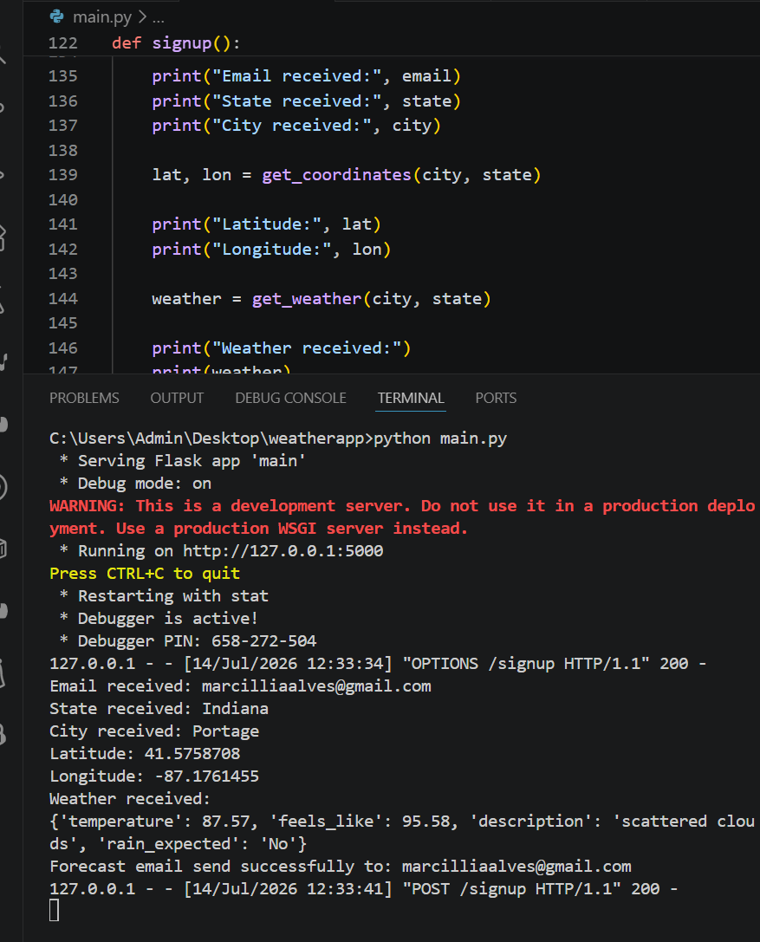
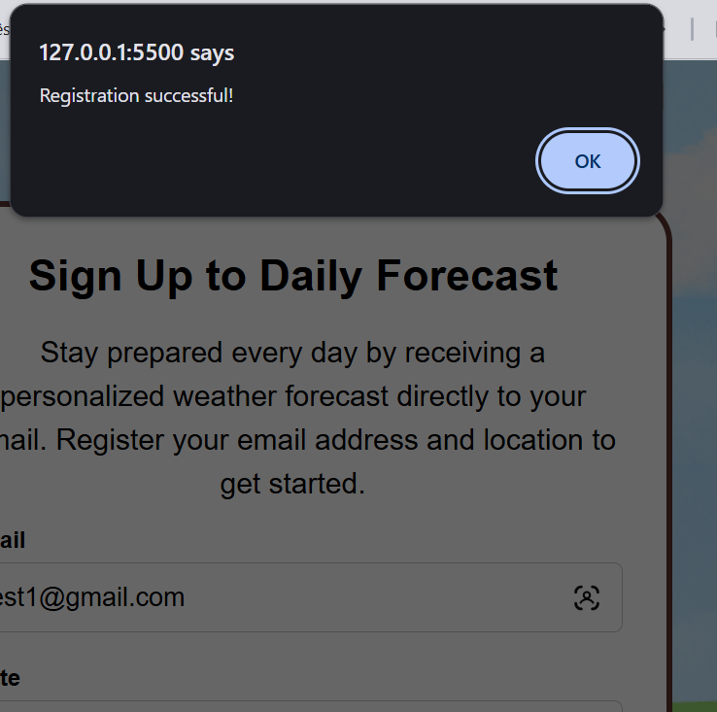
Show a valid email, selected state and city, and the successful registration message.

- Dynamic City Selection
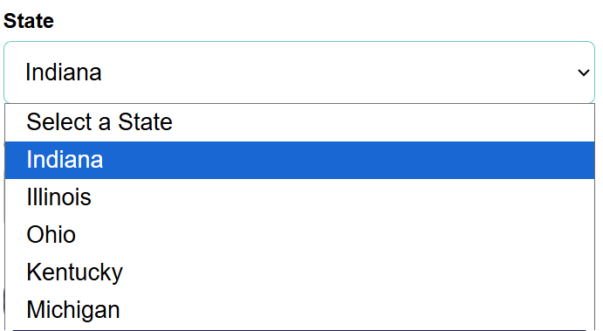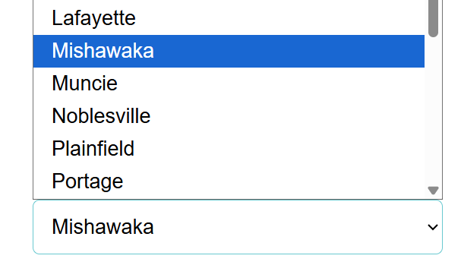
Show that selecting a state correctly populates the corresponding city dropdown.
- Existing User Update
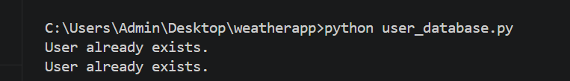
Show the same email submitted and the confirmation that the email already exists.

- Successful Unsubscribe
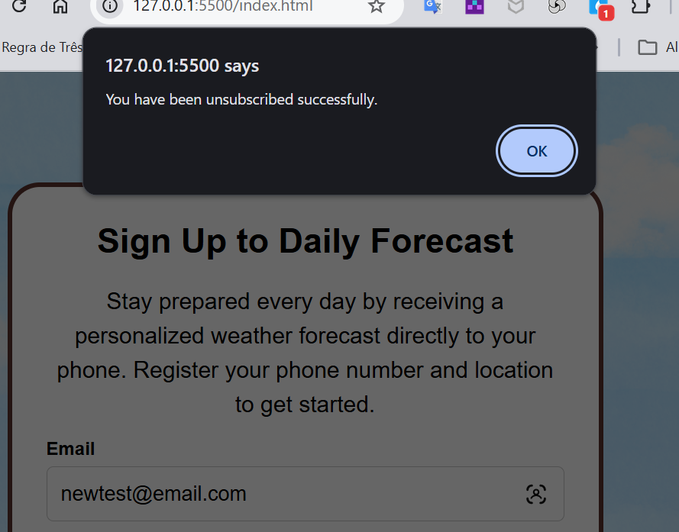
Show a registered email entered in the unsubscribe form and the confirmation message.
- Stored Test Data
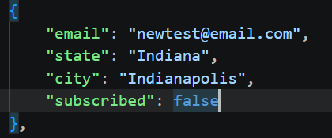
Show the corresponding record in users.json, including the email, state, city, and subscription status.

